Portumna Community School

An Maith Leat Gaeilge?
An Investigation of the Decline of Irish in Ireland.

By
Rebecca Casey

Stand number: ___________________________________
2017-2018

Comments Page

This page is dictated to all judges on the day of the 10th – 13th of January 2018.

__________________ ____________________
Student Judge

Circle date
Date: 10th / 11th / 12th / 13th January 2018

__________________ ____________________
Student Judge

Circle date
Date: 10th / 11th / 12th / 13th January 2018

__________________ ____________________
Student Judge

Circle date
Date: 10th / 11th / 12th / 13th January 2018

__________________ ____________________
Student Judge

Circle date
Date: 10th / 11th / 12th / 13th January 2018

Acknowledgements
Firstly, I would like to express my sincere gratitude to my advisor, Ms. Keena, for the continuous support of my project, for her patience, motivation, and immense knowledge. Her guidance helped me in all the time of research and writing of this project.

I thank my fellow lab mates in for the discussions, and for all the fun I have had in the last five weeks of my study.
I would like to sincerely thank all Irish teachers that supervised my procedures in their Irish classes. I especially thank Ms. Conroy and Ms. Burke for their vast amount of help and support right through my project. Without their help my project would not have run as smoothly.
Lastly, I would like to sincerely thank the TY students that helped me throughout my project. Without their help, it would have been next to impossible to carry out as many surveys as I did in the Irish classes. Thank you all for your help and contributions.

Table of Contents
Acknowledgements ii
Abstract i
Project background/development i
INTRODUCTION 2
Background 5
Previous Research 6
EXPERIMENATAL METHODS 8
Results and conclusion 21
Approach 23
data collection 24
Conclusion and reccommendations 24
Solution 25
APPENDICES 26
References: 29

Abstract
An Investigation of the Decline of the Irish language in Ireland.
Project Development and Background
The idea for this investigation came from an observation I made in class when returning from summer break in September 2017. My class and I were given a simple Irish quiz on basic Irish phrases and words and others as well as I found it difficult to answer these basic phrases that we should know from starting the language in primary school. I also made the observation when we were given topics to talk about in Irish as an oral exercise. I saw that the class struggled to speak the language even though we had just done the junior certificate prior to this.
I wanted to investigate this further so I searched if there were any articles on this on Google scholar. This brought me to the Irish times website where there was a headline on how Irish is not used as frequently within banks or ATM's. This meant that people are not using the native language outside school.
I proceeded to look up everything I could think of in relation to Irish as language e.g. people’s attitudes towards the language, how the language has declined through the years etc. A lot of the answers I was looking for appeared in the 2006 census which showed me how people felt about it and where it was declining at the fastest rate.
I decided to do my own investigation regarding this project, basing it on my first observation. I created a survey monkey for national school students to answer. On the survey monkey I asked them questions on how they felt about the subject Irish and another one on basic phrases in Irish to see if they were able to answer them. I also gave this survey by paper to the students of my current school to compare with national school students.
I analyzed the results, I then gathered the information together so I could see where students weren't using the language, how they felt towards it and a solution to furthering the language.
If we are to keep our native language alive we have to use it and keep it active in our country. I feel very passionate about Irish as a language as I am interested in the Irish history along with it. I believe that as Irish people, that are very proud of our traditions and this tradition, or native language should not die out and should be used not just in schools.

INTRODUCTION
My project is based on the Irish language and how we do not use it in our day to day lives. Irish is our native language, part of our culture and is going extinct with the lack of use.
My Project is an in-dept analyses of why we do not use our native language.
I investigated people’s attitude towards the language and why they do not use it. By using online and paper surveys, I asked questions about what they think of the language and how many people actually use it. Along with this I wanted to test people’s knowledge of Irish so I gave nine basic questions for people to answer and translate. I gave the same test to everyone no matter what level of Irish they had or what age they were.
I used a sample size of 85 students from three different year groups, 1st year, 2nd year and 5th year of which classes were picked at random. This gave me an age range from 12 years old to 17 years old.
From these charts below you can see the overall results of which the students answered the survey and test.

Background

Our inspiration came from the first of many visits to my relative, Ned Burns; who designed the speedflexer. On the first visit, Ned Burns measured my flexibility on his personally designed speedflexer. Subsequently, Ned Burns informed Fiachra that his flexibility needed massive improvement. Ned Burns strongly advised some specialised flexibility exercises for Fiachra to implement into his daily routine. Fiachra religiously completed these exercises for one month with Ned’s perseverance. Fiachra’s flexibility hadn’t improved to the expected targets. The flexibility results were only marginally better. Ned Burns was baffled with the outcome of the results after he had witnessed Fiachra’s vigorous completion of the exercises along with designing the actual speedflexer used to test Fiachra’s flexibility. This is where the fundamental concept and motivation to our young scientist project came from.

Previous Research
In this section, relevant information was reviewed in order to replace the research hypothesis within the field of investigation. The information I reviewed here includes the Junior Certificate and Leaving Certificate percentage breakdown of candidates by the grade awarded in each subject, percentage of people that speak Irish in their county and percentages of peoples’ attitude towards the Irish language. The information that was reviewed included a statistical table of the years, grades, levels and percentages for each subject, provided by the State Examination Commission, a percentage table for Irish speaking counties and a percentage table of peoples’ attitude towards the Irish language. This review of information has been written with the purpose of learning about the statistical percentages of candidates that achieved a grade in each subject.
Leaving Certificate: Subject – Irish.
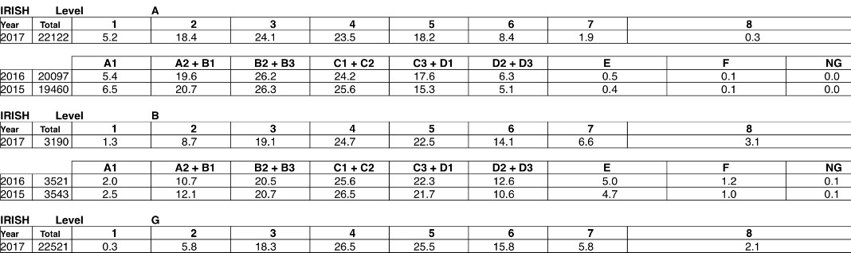
As you can see in Leaving Certificate Irish, grades are beginning to lower each year.
“This year, 5.2 per cent of candidates got a H1, although this is down slightly compared to 2015 and 2016 where 6.5 and 5.4 per cent came out on top. Overall, a not-too-shabby 89.4 per cent of higher-level students got between a H1 and H5.”
-Irish times
Girls outperformed boys at higher level in a number of subjects including Irish, history, geography, French, business studies, music and science where 2,567 girls scored an A grade compared to 1,730 boys.
-Irish Independent

Percentages of Irish spoke in each county highest to lowest.
County Irish %
1.Clare: 48.8 2.Kerry: 47.2 2.Mayo: 47.2 3.Cork 46.6 3.Limerick: 46.6 4.Tipperary: 45 4.Roscommon: 45 5.Waterford 44.2 6.Sligo 43.9 7.Kilkenny 43.5 8.Leitrim 43.1 9.Laois 42.6 10.Kildare 42.4 11.Westmeath 41.5 12.Longford 41.2 13.Meath 40.1 14.Monaghan 39.6 14.Donegal 39.6 15.Carlow 39.5 15.Offaly 39 16.Wicklow 38 17.Cavan 38 18.Wexford 37.4 19.Dublin 37.2 20.Louth 36.7 21.Galway 24.6

Percentages of peoples’ attitude towards the Irish language from the 2006 census.
Republic Of Ireland Northern Ireland
Positive: 67% 45%
Negative: 33% 55%
Plays a role in Heritage & culture 64% 33%
Government influence 53% 34%
As you can see here it is split up into the Republic of Ireland and Northern Ireland. 67% in the Republic of Ireland have a positive attitude to Irish as a language. 55% of Northern Irish people have a negative attitude to the Irish language, but this is usually due to history and them being a part of Great Britain. In the Republic, almost two-thirds (64 percent) believe that Ireland would lose its identity without the Irish language. However, a significantly smaller (33 per cent) proportion of Northern Irish residents shared this view. There were notably mixed views on the level of involvement that the Government should have in preservation/promotion of the Irish language; in the Republic of Ireland there was a significantly stronger feeling that the Government should ensure that Irish is taught well in schools (53 per cent), in contrast to a third of those in Northern Ireland (34 per cent).

EXPERIMENATAL METHODS
The experimental methods that I used for this investigation were online research, online surveys (survey monkey) and paper surveys.
Here is the online survey that I used for my project:
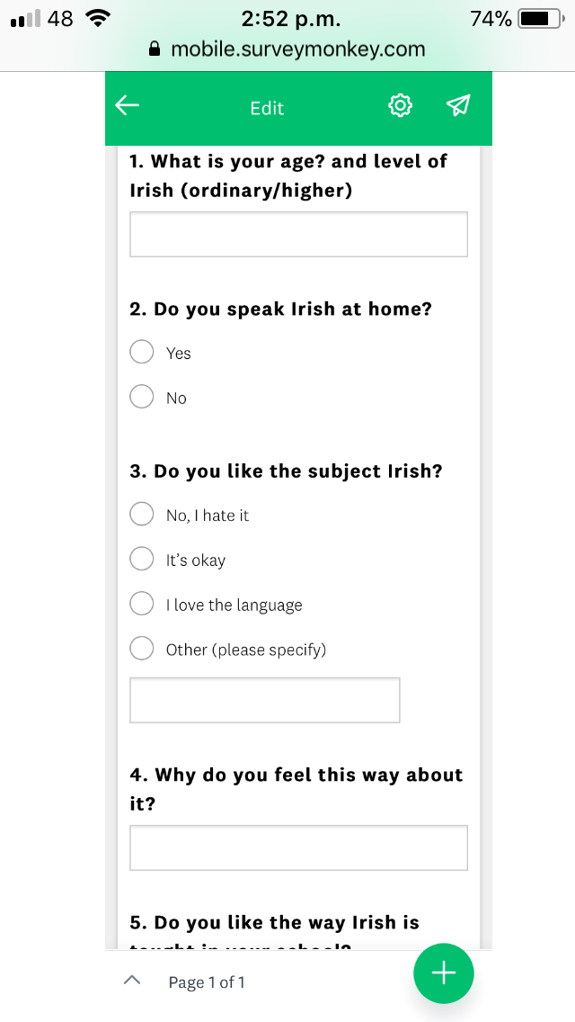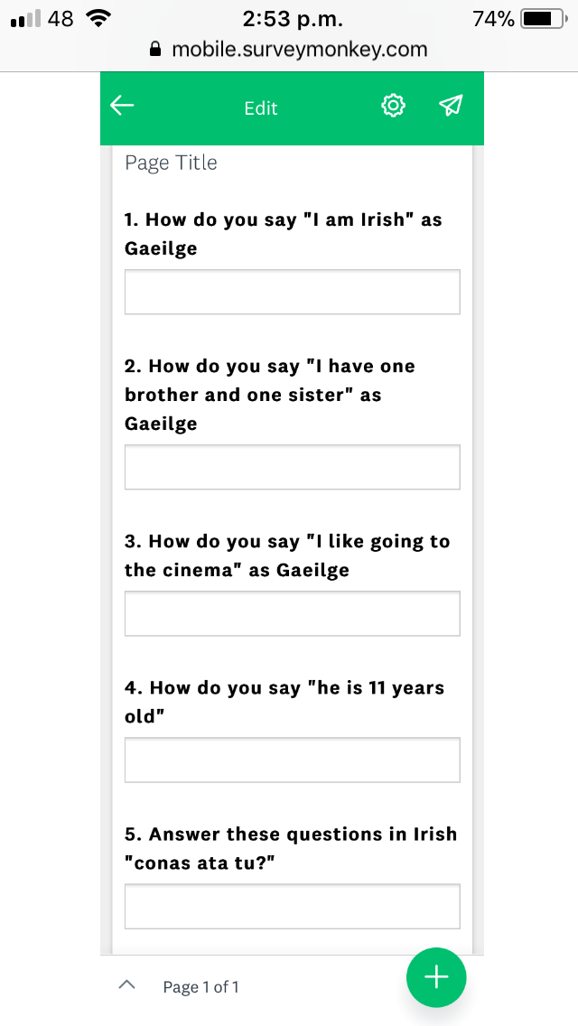

Here is the paper survey I used:

Irish Survey for BT Young Scientist.
Age:
Are you male or female?
Level of Irish: Higher Ordinary

Do you speak Irish at home?
Yes No
Do you like the subject Irish?
Yes, I love the subject.
It’s okay.
No, I hate it.
Other:
Why do you feel this way about the subject?

How are you examined in class in Irish?
Spelling tests
Oral tests (speaking tests)
Monthly tests
I’m not examined in class in Irish
Do you think you are good at Irish?
Yes
I’m ok at it.
No
Why do you think this?
I can’t understand my teacher’s methods The syllabus is too difficult
I’m bad at languages I’m good at languages
The course is easy
Other:
Do you like the way Irish is taught in your school ?
Yes No
Why?

Translate these sentences into Irish.
I am Irish:

I have one brother and one sister:

I like going to the cinema with my friends.

He is 11 years old:

I want to get a good job.

Answer these questions in Irish.
Conas ata tu?

Ca bhfuil tu ina chonai?

An bhfuil peata agat?

Cad ata tu ag dheanamh innu?

Analyses of questions
Q1 “Do you speak Irish at home?”
I asked this question to see how many families use Irish in their homes daily.
Q2 “Do you like the subject Irish”
This question shows peoples attitude towards Irish as a subject.
Q3 “Why do you feel this way about the subject?”
This question gives a clear answer on why people do/do not like Irish.
Q4 “How are you examined in Irish class”
This was to see if the way Irish is taught in class effects how people’s attitudes towards Irish.
Q5 “Do you think you are good at Irish”
This question was asked to see people’s confidence in using the language
Q6 “Why do you think this?”
I asked this question to see if people’s attitudes are directed by themselves or school.
Q7 “ Do you like the way Irish is taught in your school”
This was to see if people like the way they are made learn the subject.
Q8 “Why”
This was to see clearly people’s attitude towards Irish as a subject and its teaching.

These are the percentages of each age surveyed. The range consists from 12 years old to 17 years old, 1st year, 2nd year, Transition year and 5th year.

1st year 2nd year

Transition Year 5th year

.

The results from this question showed that the youngest group which are in 1st year do not speak Irish in their homes.
In 2nd year only 14% speak Irish in their homes.
In Transition year larger percentage of 27 speak Irish in their homes.
From this question it showed that only 6% of the oldest group, 5th years surveyed speak Irish in their homes.

The 1st year group had only 7% that had a love for the language where are further were unsure about their preference of the subject. The 1st year group had the largest percentage of dislike to the subject (47%)
The 2nd year group said that 5% of them have a love for the language, 86% didn’t have a definite preference and they also had to lowest dislike to the subject of 9%
The Transition year group had the largest interest in Irish (26%). 67% of TY’s didn’t have a preference and 12% of them said they disliked the subject, Irish.
The 5th year group had a very mixed view on the subject, 12% said that they had a love for the subject, 63% said it’s okay and 25% said that he strongly disliked it.

Different groups had different main reasons on why they mainly did not like the subject. In 1st year they said their main reason was that they found the subject too difficult for them. This is also the case in 2nd year and TY. However in 5th year their main issue is that they do not like their course layout.

These results from this question shows what testing methods are being used the most or least in their classes.

In 1st year there were more people who did not think they were good at Irish (33%) and only 13% said they are not good at Irish. In 2nd year there is more confidence in their Irish ability (24%) and 14% said they are not good at the subject. In TY 40% said that their ability on Irish is lacking, although 27% of the year said that they are good at Irish. In 5th year there was a very low percentage of each, 9% said that they were not good at Irish and a higher 20% said that they were good at the language.

One of the main reasons that all the groups about them not being good at Irish that was gave was that they think that they are bad at languages even though they have been learning it from aprox. 2nd class.
Positive reasons given were that the course was easy; some said they were good at languages and that their teacher was helpful.

In 1st and 2nd year, the results show that they are happy with the way Irish is taught in their school. 60% of 1st year and 76% of 2nd year show that they are happy with the teaching methods.
However, in TY 57% said they did not like the way Irish is taught in their school and 56% of 5th year also said this.

1st and 2nd year said that they were happy with the teachings because their teachers are helpful and it is easy to understand under the type of teaching used.
In TY 23% said that the course is not practical e.g learning poems. In 5th year a larger number of 40% say it is not practical also.

RESULTS AND CONCLUSIONS
At the end of my investigation it was found that there were a greater percentage of negative attitudes towards Irish than positive. Because people said that they did not like the language their test results were low.

These tables indicate the positive answers to the survey and the negative answers to the survey for comparison.
(People who said they did not have a preference (answered “okay”) were excluded from these results)

Positive answers towards Irish:
 | 1st year | 2nd year | Transition Year | 5th year
Question 1  1%-bad  100%-good | 0% | 14% | 27% | 6%
Question 2  1%-bad  100%-good | 7% | 5% | 26% | 12%
Question 3  1%-bad  100%-good | 6% | 28% | 17% | 7%
Question 4  1%-good  100%-bad | 33% | 24% | 40% | 9%
Question 5  100%-good  1%-bad | 33% | 33% | 31% | 11%
Question 6  100%-good  1%-bad | 60% | 76% | 43% | 44%
Question 7  100%- good  1%- bad | 62% | 33% | 39% | 40%
Average Percentage | 29% | 30% | 31% | 18%

Negative answers to Irish (% of negativity)

 | 1st year | 2nd year | Transition Year | 5th year
Question 1 | 100% | 86% | 73% | 94%
Question 2 | 47% | 9% | 12% | 25%
Question 3 | 94% | 72% | 83% | 25%
Question 4 | 33% | 14% | 40% | 9%
Question 5 | 67% | 67% | 69% | 89%
Question 6 | 20% | 24% | 57% | 56%
Question 7 | 28% | 24% | 61% | 60%
Average Percentage | 56% | 42% | 56% | 51%

Average Test results taken by sample groups
1st year average – 48%
2nd year average – 44%
Transition Year – 62%
5th year average – 58%

Approach
- Do research on Irish as a language, areas of use and how much it’s used. Research videos of studies done like mine and of people’s attitude towards Irish.

- Create a survey and test to give to three classes of different ages, year group and at random.

- Analyse results of survey and test.

- Compare and contrast results of test to different year groups.

- Research the grade percentages of Leaving Cert Irish to compare results to.

- Devise a solution based on the results received.

DATA COLLECTION

Conclusions and recommendations:
The results of the study show that there is more of a negative attitude towards the Irish language. From my study it has shown that test results were low when people said they disliked this. I can now conclude that students that I had surveyed do not like Irish and did not do well in answering basic phrases of Irish. The Irish leaving certificate results prove my conclusion also as they are decreasing each year, which would be a big problem for our country’s native language.
Here is the year groups best ability and lowest ability to answer basic Irish phrases.
 | Best score | Poorest score
1st year | 67% | 11%
2nd year | 78% | 11%
Transition Year | 100% | 0%
5th year | 100% | 11%

If I was to do this project again from the start one thing I would do is use a larger sample. I had approx. 85 students between the age of 12 and 17 from the four year groups. I was unable to survey 3rd year and 6th year students due to exams. I would also like to survey national school children to see their answers to basic phrases compared to secondary school students. This was unsuccessful for me when I tried it for this project. A larger sample would give me complete analyses of 12-18 year olds attitudes and their use of Irish.
The second thing I would do is do a course with national school pupils or get the teachers to use Irish in different subjects for a week to see if their Irish had improved orally and written.
Finally, if I was doing this project again I would pay more attention to my survey questions and add more in to get more information.

SOLUTION
From doing my survey and test I received a lot of feedback of what students find challenging about the Irish language and suggested potential solutions to their challenges. I analysed all my results to see potential solutions to this occurring problem in our country. Here are the potential solutions that I have devised and that have been suggested by students.

1. Irish should be started at an earlier age.
Students that said they have gone to an all-Irish speaking national school said that they found Irish easy as they have been using it since junior infants.
If we introduced Irish into national schools at an earlier age, children would learn it easier which would benefit them and the culture of the language in the future.

2. Irish should be used in more subjects in national school.
If students are writing Irish only Irish class they are not actively learning it as a language. If Irish was introduced into other subject e.g. physical education they would use and understand the language more.

3. Irish should be taught more orally than written.

A lot of students said that they would like if the Irish language was taught more orally. Even though students said that the new Irish course is easier and more student-based. They would like to see more oral teaching in the subject.

4. Irish should be used after school e.g jobs
Irish is not used after school unless it is specifically used in people’s jobs or on legal documents or laws that have been translated to English. If people were so familiar with Irish from the effective work in school, it could be introduced in the work place or in situations e.g. greetings, shops. If Irish was used in the world of work and not just for a college course it would keep our Irish language alive and active in our country.

APPENDICES
Irish Survey for BT Young Scientist.
Age:
Are you male or female?
Level of Irish: Higher Ordinary

Do you speak Irish at home?
Yes No
Do you like the subject Irish?
Yes, I love the subject.
It’s okay.
No, I hate it.
Other:
Why do you feel this way about the subject?

How are you examined in class in Irish?
Spelling tests
Oral tests (speaking tests)
Monthly tests
I’m not examined in class in Irish
Do you think you are good at Irish?
Yes
I’m ok at it.
No
Why do you think this?
I can’t understand my teacher’s methods The syllabus is too difficult
I’m bad at languages I’m good at languages
The course is easy
Other:
Do you like the way Irish is taught in your school?
Yes
No
Why?

Translate these sentences into Irish.
I am Irish:

I have one brother and one sister:

I like going to the cinema with my friends.

He is 11 years old:

I want to get a good job.

Answer these questions in Irish.
Conas ata tu?

Ca bhfuil tu ina chonai?

An bhfuil peata agat?

Cad ata tu ag dheanamh innu?

References:
1. Cardiovascular responses to passive static exercises are influenced by the stretched muscle mass and Valsalva Manoeuvre (2011), Faranatti et al.
2. Comparative Study of 3 Stretching Techniques: (1970) Ted Okita
(http://www.amsciepub.com/doi/pdf/10.2466/pms.197 0.31.2.611)
3.The effect of time on Static Stretches of Hamstring Muscles: (1998), William D. Bandy. (http://www.udel.edu/PT/PT%20Clinical%20Services/journalclub/sojc/97_98/mar98/bandy.pdf)
4. Eccentric Training and static stretching to improve hamstring flexibility of High school males, Russel T. Nelson, (2004)
http://www.ncbi.nlm.nih.gov/pmc/articles/PMC522148/
5. Abdominal and hip flexor muscle activation during various exercises, Nilsson J, (1997) http://www.ncbi.nlm.nih.gov/pubmed/9118976
6. Acute changes in hamstring flexibility…PNF vs. static stretches on senior athletes, J. Brent Ferland (2001).
7. Flexibility and Its Effects on Sports Injury and Performance, Gilbert W. Gleim (20

